Guiding Principles for Equitable Design for Children and Youth
Mapping assets within organizations that support developmental practices

Developmental practices are the dynamic supports young people need, in different ways and from different people, throughout their lives. Adults can learn these practices, and develop strategies for putting them in place, whenever and wherever they engage with young people.
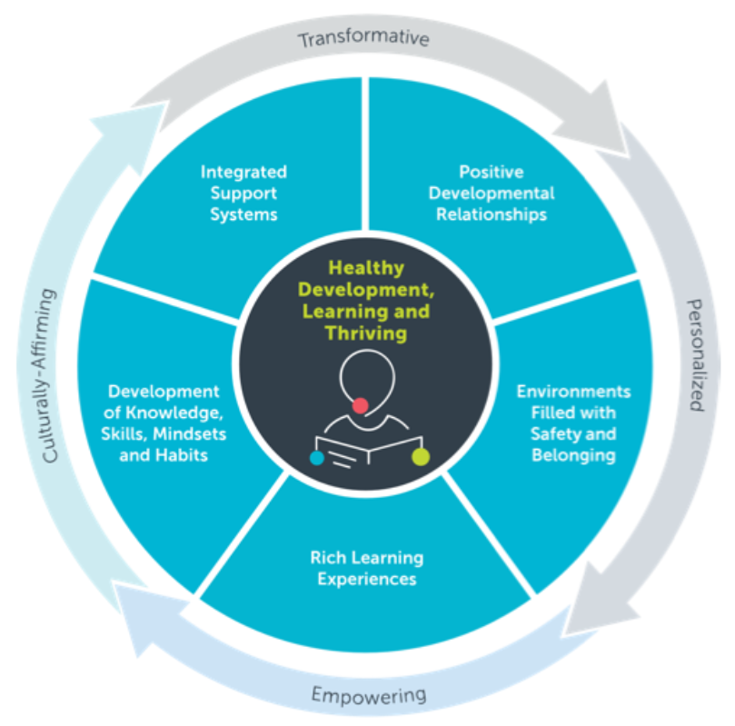
WHY FOCUS ON DEVELOPMENTAL PRACTICE?
How much are developmental practices actually codified and supported within your organization? A wealth of science tells us the elements of practice depicted on the graphic are essential for development. By ensuring people have these supports, we optimize their ability to experience whatever it is we want them to experience. There are likely many policies, practices, procedures and programs that your organization says should explicitly support these practices. There could also be mandates that your organization requires that seem counter to these practices.
Why is it important to explore this question? Research has shown that if front-line staff and administrators do not get signals that they should proactively take specific actions in their work they will tend to be risk-averse or assume that the positive developmental practices that they are employing are actually exceptions to the institutional expectations. By reviewing our current operating procedures, policies and practices against the research of what makes a difference, we can work together to ensure that every young person is receiving the most effective services, supports and opportunities possible.
Graphic:
Science of Learning and Development Initiative, Turnaround for Children

The five elements above provide the framing for this asset map.

The latest in the science of learning and development affirms that learning is optimized when it starts with strong relationships in environments filled with safety and belonging. In these contexts, children and youth can then fully engage in challenging experiences and opportunities. Intentional development of skills, mindsets and habits can be best maximized when these other components are in place. Optimal learning and engagement also requires personalization – individualized supports – that takes into account a young person’s specific needs.

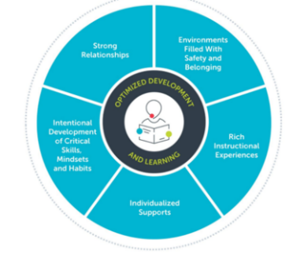
Guiding Principles of Developmental Practice:
How Important? How Much Practiced?
How much are developmental practices actually codified and supported within your organization? A wealth of science tells us these elements of practice are essential for development. By ensuring people have these supports, we optimize their ability to experience whatever it is we want them to experience. There are likely many policies, practices, procedures and programs that your organization says should explicitly support these practices. There could also be mandates that your organization requires that seem counter to these practices. This questionnaire is designed as a first step in a conversation with your colleagues and counterparts about how you are defining and supporting developmental practices.
Instructions: Using the columns on the right, please rate each of the below categories from 1 (low) to 5 (high) on how important you feel it is and how well it is currently being practiced across your program, organization, agency, or system. |  | HOW IMPORTANT?  1 (low) – 5 (High) | How much practiced?  1 (low) – 5 (High)
Positive developmental relationshipS | Form developmental relationships between adults and young people that promote leadership and help young people discover their strengths, expand their possibilities, and challenge growth.
 | Foster meaningful relationships among young people across shared identity and difference and building intentional connection around shared experiences.
 | Cultivate relationships with family members using a strengths-based lens that provides opportunities for engagement and collaborative decision-making
ENVIRONMENTS FILLED WITH  SAFETY & BELONGING | Cultivate safety and consistency, implementing routines that support risk-taking, helping young people build personal connections and a sense of purpose for themselves, Use restorative practices to help young people to reflect on any mistake, solve conflicts, and get counseling when needed
 | Build community using positive behavior management practices, fostering positive peer to peer relationships, and co-developing program expectations with young people.
 | Be culturally responsive and inclusive, using affirmations that establish the value of every young persons’ many identities and abilities, building on the diversity and cultural knowledge of young people and their families, and developing young people’s knowledge, skills, and agency to critically engage in civic affairs.
RICH INSTRUCTIONAL  EXPERIENCES | Use scaffolding and differentiation techniques to support individual learning styles, assessing and adjusting programming to fit the interests, strengths, and needs of young people while providing asset based personalized supports as well as fostering cooperative learning.
 | Facilitate inquiry-based approaches to learning to help youth be active learners, providing regular and thoughtful feedback and creating opportunities for young people to reflect and revise.
 | Adopt a culturally responsive approach to learning by explicitly connecting students’ diverse experiences and cultural assets with program content, promote racial-ethnic identity development, voice, and agency, and facilitating conversations around equity and social justice.
Development of skills, mindsets and habits | Integrate social and emotional learning in a culturally responsive context, fostering awareness and understanding of young peoples’ emotions, providing them with strategies that supports them to both express and manage emotions, and doing so in a way that ensures cultural sensitivity and responsiveness.
 | Develop productive mindsets and habits by nurturing growth mindset, providing opportunities for planning and goal setting, and supporting interpersonal skills like empathy, collaboration and problem solving.
 | Incorporate healing-centered practices, employing responsive strategies based on the principles of safety, trust, collaboration, choice, and empowerment and promoting physical and mental wellbeing through mindfulness strategies, breathing exercises, and other stress.
INTEgrated Support Systems | Connect youth to supplemental learning opportunities by partnering with schools to provide seamless and aligned supports, monitoring young people’s academic growth, and adding adult capacity to the school day.
 | Promote access to other supports and opportunities that foster health and well-being by ensuring mechanisms and partnerships are in place to connect families and youth to basic needs such as food, health, and mental health in addition to academic supports and participating in whole-school comprehensive community partnership models.

Stephanie Malia Krauss, Karen Pittman, and Caitlin Johnson; The Forum for Youth Investment (2016) Ready by Design: The Science (and Art) of Youth Readiness.
Linda Darling-Hammond, Lisa Flook, Channa Cook-Harvey, Brigid Barron & David Osher (2019) Implications for educational practice of the science of learning and development, Applied Developmental Science.
The Forum for Youth Investment (2014) Collective Impact for Policymakers: Working Together for Children and Youth. https://forumfyi.org/knowledge-center/collective-impact-for-policymakers/

