96

Continuous Improvement Reflection Tool
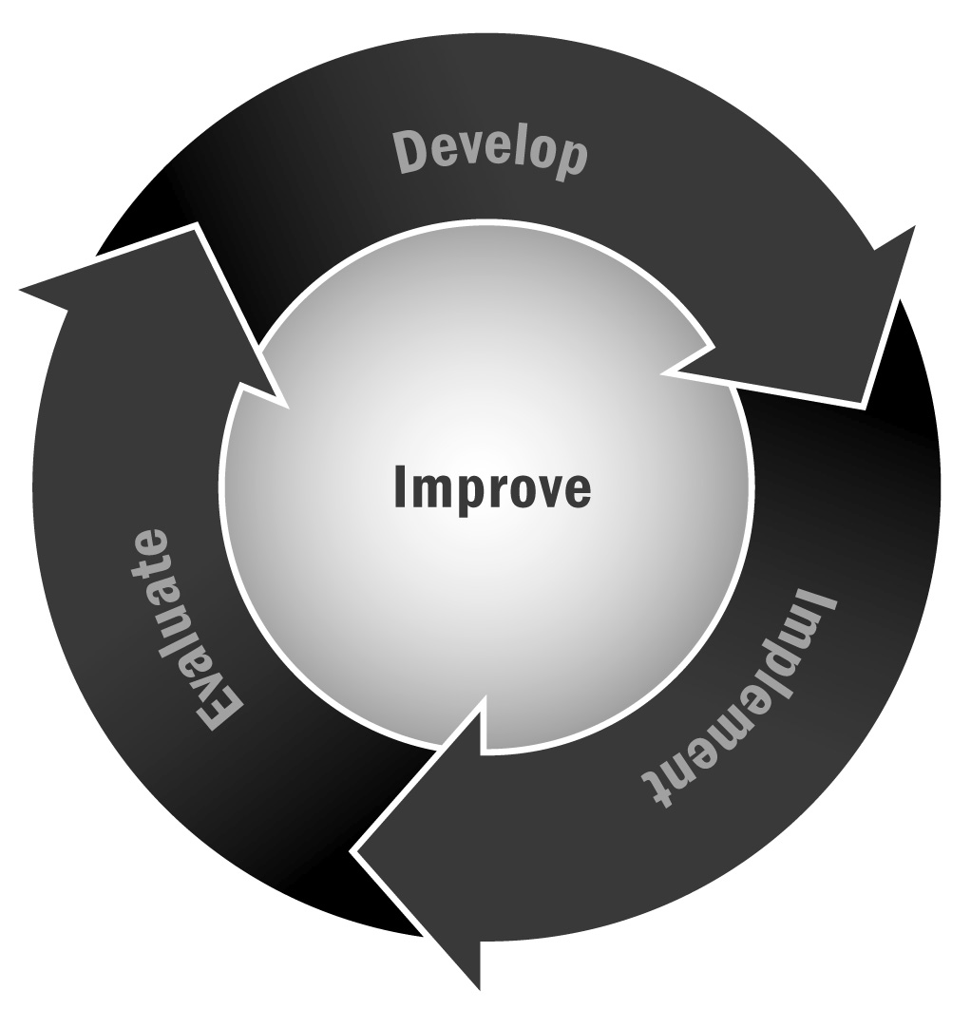
Throughout this guide, and in particular in Chapter 6, you learned about the importance of embedding a continuous cycle of planning, implementing, evaluating, and improving in your program. In order to do this, you have to plan for and implement a continuous improvement process that builds upon all you have learned in this guide.
Directions: This tool is designed take you through a reflection process for the various sections of this Toolkit. You may not need to revisit everything in here all at once. In fact, we recommend you review the whole document as a reminder of what you should constantly reflect on, review, and revise as your program evolves—but take one chunk or section to review at a time so that it doesn’t become overwhelming. We also recommend that you bring together your advisory board, staff, families, youth and other key stakeholders in your reflection process as appropriate for each stage. For each step, we’ve listed a set of questions or issues to consider and have provided space for you to reflect and make notes. At the end, we’ve included some exercises and planning suggestions for embedding a culture of continuous improvement in your program.

Reflection Questions for Continuous Improvement
Management Practices |  | Notes
Organizational Structures | Is our management and organizational structure still working?  Revisit your advisory board membership:  - Are all of our key stakeholders represented? Do we need to add anyone?  - Is our meeting schedule allowing us to accomplish what we want? (Too often? Not often enough?)
Staffing | Are our job descriptions up to date and do they reflect our current program structure?  Are we able to recruit highly qualified and effective staff members? If not, why not? What can we change?  Is our orientation process for new and returning staff members still preparing our staff adequately? What might we need to change?  Are our staffing policies and procedures still appropriate for our organizational structure and our program’s developmental stage?
Policies and Procedures | Revisit the following policies and procedures. Are they still appropriate? Are they meeting our needs? Do we need to revise any based on changes in your program?  - Participant recruitment, enrollment and attendance  - Ratios  - Background checks and other safety procedures  - Behavior guidelines and discipline  - Program schedule
Resource Management | Are there new funders we should be targeting as our program grows and develops?  Are there new funding strategies we haven’t considered (e.g., program fees, donors, special events)?  Are our financial procedures still appropriate as our program has grown? Do we need to revisit our accounting practices?
Communication | What are our communication goals for the coming year?  What key messages do we want to convey about our program at this stage in our development?  Are we communicating effectively with families? The community? Key policymakers? Funders? How can we improve our messaging?  Are there any audiences we aren’t reaching that we should be?

Program Design |  | Notes
Vision | Is our vision still appropriate? Does it still reflect what we are trying to accomplish with our program?
Goals | Is our program adequately working toward accomplishing our goals?  Are our goals still appropriate? Are any unrealistic?  Do we need to change or add any program goals to reflect the developmental stage of our program?
Theory of Change | Does our program implementation reflect our theory of change? Are we deviating from our planned activities?  Does our theory of change still seem appropriate?
Logic Model | Does our logic model still reflect our program?  Have our goals or intended outcomes changed? If yes, how?  Can we add any inputs or outputs to the logic model now that our program has been under way for some time?

Partnerships |  | Notes
School | How is our school partnership progressing?  What can we do to better connect with school administration?  What can we do to better connect with school faculty?  What do we need from the school? How can we get it?  What data are we sharing with the school, if any? How can we connect those data to our participation data?
Family | How well are families engaged in our program?  What else can we do to engage families appropriately?  What roles can family members play now that our program is up and running?
Community | What partnerships with community organizations are particularly successful? Which aren’t going so well?  What community organizations should we target for partnerships? What community resources could we be using better?

Program Delivery |  | Notes
Program Plan | Does our program plan match our program goals and intended outcomes?  Does our program schedule/plan meet the needs of youth and their families? If not, what changes can we make to better meet their needs? Consider things like:  - Program schedule—do the hours meet the needs of working parents? If we aren’t offering the program five days a week, should we add more days? How many weeks per year are we offering programs? Do we need to adjust that?  - Summer program—should we offer one?  - Does our session structure work for families?  - Transportation—are youth getting home safely? Do we need to revisit our transportation options?
Activities | Does our mix of program activities still reflect the assets, interests, and needs of youth and their families? In what ways do we need to change or add to our programming to better build on young people’s strengths?  What activities would we like to offer if we can find staff members or providers to deliver them?  Does our mix of program activities still reflect our program goals? Is it helping us work toward our intended outcomes? What changes do we need to make?

Evaluation |  | Notes
Evaluation Questions | How can our evaluation questions better match our program goals and intended outcomes?  What do we want to know?  Are there things we want to explore on a regular basis?
Data Collection System | Is our data collection system allowing us to capture the data we want? What can be improved?  What additional data do we want to track? Will we need to make changes to our data system to allow that?
Use of Data | What data are we examining on a regular basis?  Are there other data we could examine and discuss regularly to better serve youth in our program?  Are there data we could examine regularly in partnership with the school in order to target or serve specific youth?  What are our attendance data telling us?

Improvement Planning |  | Notes
Quality Improvement Planning | What data about our program quality do we want to capture?  Do we want to use a quality assessment tool? Which one?  What professional development and training does our staff need? How can we access it?  What can we learn from our quality assessment data? What changes to our program do we want to make?  How are we doing in implementing youth development practices, including:  - Creating a warm and welcoming environment?  - Building supportive relationships?  - Promoting positive behavior management?  - Offering youth choices?  - Providing youth with opportunities for decision-making?  - Providing youth with opportunities for leadership?  - Making time for reflection?  What coaching do we need for our staff? How will we get it?
Continuous Improvement Practices | How can our program leadership better promote and support improvement?  Are we sharing evaluation results with all staff members? How can we engage staff members more fully in evaluation planning and reviewing evaluation results?  Are we incorporating reflection into our staff meetings?  How can we keep stakeholders informed about and engaged in improvement planning? What is working? What could we try next?
What’s Next? After engaging in conversation with your staff, partners, and other key stakeholders about any of the sections above, identify some key action steps and who is responsible for carrying them out. Use the table below to formalize those action steps and monitor their progress. This table can then become fodder for the next round of reflection and improvement so that reflection, planning for action, acting, and reviewing can become a constant process.

Planning for Continuous Improvement
Management Practices
Program Area | Next Steps | Who Is Responsible
Organizational Structures
Staffing
Policies and Procedures
Resource Management
Communications
Program Design
Program Area | Next Steps | Who Is Responsible
Vision
Goals
Theory of Change
Logic Model
Partnerships
Program Area | Next Steps | Who Is Responsible
School
Family
Community
Program Delivery
Program Area | Next Steps | Who Is Responsible
Program Plan
Activities
Evaluation
Program Area | Next Steps | Who Is Responsible
Evaluation Questions
Data Collection System
Use of Data
Improvement Planning
Program Area | Next Steps | Who Is Responsible
Quality Improvement Planning
Continuous Improvement Practices

