7

Tips for Developing Outreach and Marketing Materials
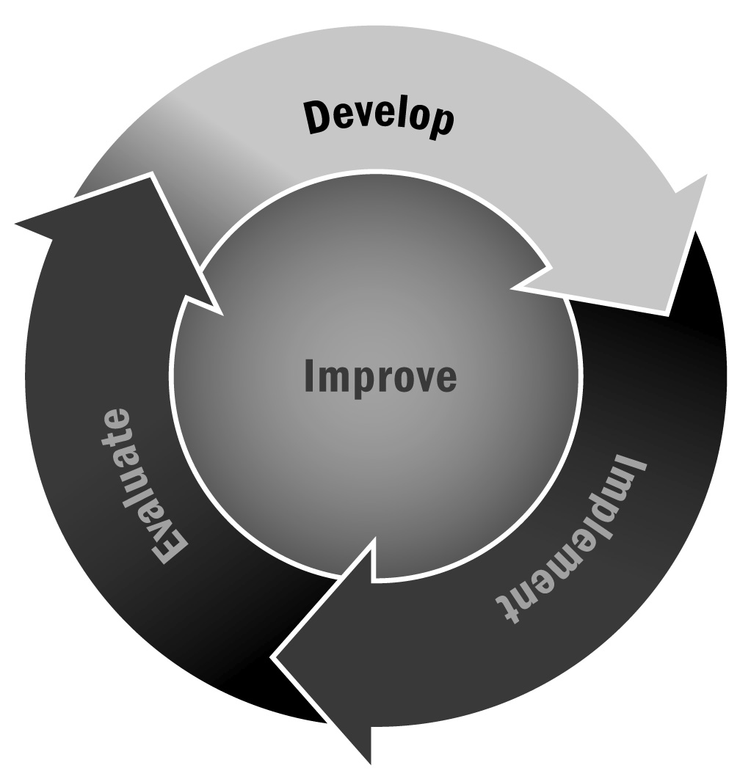
In Chapter 1, you learned that it is important to develop materials that provide clear information about your program that you can share with schools, families, community partners, and the media. Getting the word out about your program will support your recruitment, retention, and marketing efforts, and it will also help staff members and stakeholders develop a sense of identity for your program.
Directions: Consider the following tips as you think about outreach and marketing materials for your program. These materials may take many different forms, such as a one-page information sheet, a brochure, posters, or a flyer. You may want to develop these materials with middle or high school students in your program and/or consider enlisting the aid of a graphic artist or printer in the community.
Before you begin developing your materials:
- Collect materials from other programs and agencies. You can find these by visiting different organizations in person or viewing their websites. Identify what it is about those materials that you find attractive, and identify what you don’t like. Use these characteristics to guide your thinking.
- Determine how much money you can spend on your materials, and stick to the budget.
- If you are printing materials, identify how many copies you will need.
Developing your materials:
- Think about the purpose of the materials you are developing. What do you want them to achieve? Some purposes might be:
- To inform potential participants about the program
- To secure funding for the program
- To educate nonparticipants about the program
- Next, identify your audience. As you start writing, keep that audience in mind and use words and phrasing that are both familiar and appealing to them.
- Write from the reader’s point of view. Focus your writing on what matters most to that specific audience. If families are your focus, you might highlight the importance of youth having a safe place to spend their time out of school, whereas if your focus is community members you might highlight the service learning projects your program plans for the upcoming year.
- Use simple language that is clear. Avoid “talking down” to your audience, but make sure that the language you use is easy to understand for a variety of readers.

- Use words and phrases that engage the reader. Avoid clichés and jargon. For example, most afterschool and expanded learning programs claim to be “committed to student success,” and many say they’re “standards based.” What exactly do those phrases mean? Be sure your materials convey the point of your message clearly.
- Emphasize the benefits of your program rather than its features. For example, write this: “Young people will complete their homework at the program every day,” rather than this: “The first hour is devoted to homework assistance. Tutors are available to help youth.”
- Use a simple design for your materials. Whatever you create should not attempt to be a comprehensive manual detailing every aspect of your program, and you should avoid creating something that has every inch of space covered with text or images. Instead, make sure that there are only two or three sentences per paragraph and fewer than 10 lines of type per paragraph. Use bold or italic type sparingly to emphasize a point. Avoid using underlining or all caps. These styles are leftovers from the typewriter age!
- Choose potential images for your materials, if necessary. Photos of youth from your program are always good, but require that the materials be printed directly. (If photocopied, photographs often lose their clarity.) Using photos of youth in your program also requires family permission, so make sure you obtain that from families first!
- Choose your paper, ink, and font colors and texture with care. Remember…
- Glossy paper with bold colors creates an upscale image, while plain copier paper creates a poor image.
- Dark ink works best for most type, although brighter colors can be used for headings.
- Extra ink colors often translate into extra charges.
- Select fonts with an eye to the message you want to convey. Do not use more than three fonts in your brochure. The fonts you use the most should carry your message and be easy to read.
- Check with your printer about supplies that he or she may have in stock. Sometimes a printer can offer you a deal if you will use up the rest of some “expensive” materials purchased for another job.
- Emphasize your program’s name and logo. This should be the first thing the reader will see. It should jump out and seize the reader’s attention. Also be sure to include contact information.
Once you are finished:
- Distribute your materials! Even an excellent information sheet won’t be helpful unless it is received by people, organizations, and agencies in the community.
- Evaluate your communication and supporting materials for ongoing improvement!

