37

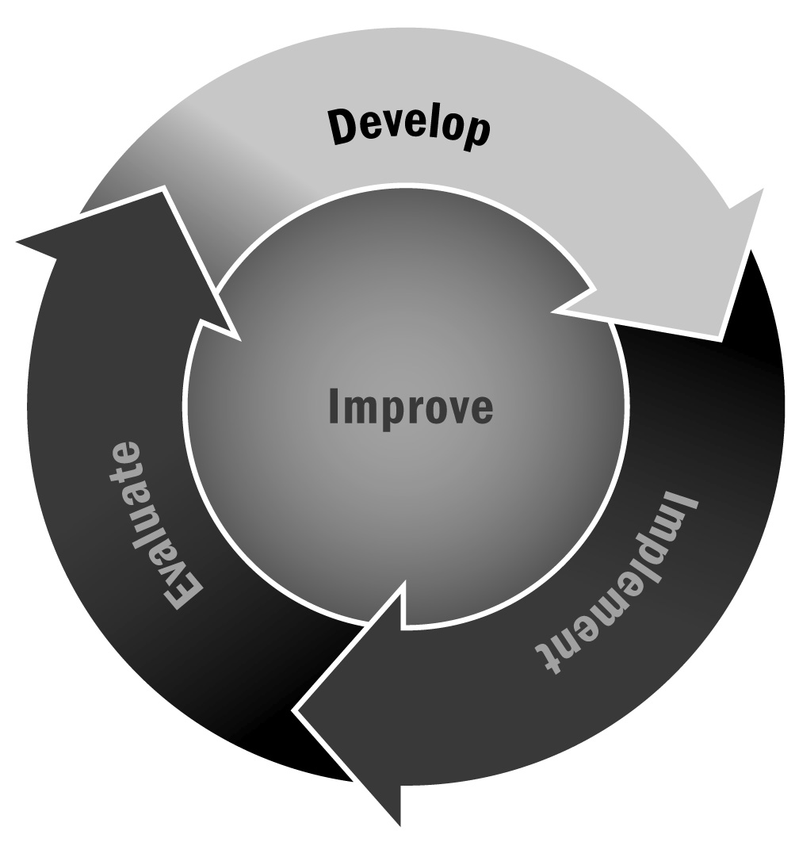
Goal Setting Worksheet
In Chapter 2, you learned about the importance of creating a strong program vision and a set of goals related to how you are going to accomplish that vision. Having a clear set of goals can be important for ensuring that everyone associated with your program is working toward the same purpose.
Directions: This worksheet can be used to record both goal areas and specific goals. First, write down the vision statement you created with your stakeholders. Do not attempt to create goals without first knowing your vision. Next, think about the areas in which you want to set goals. Record these in the column on the left. A few examples are provided to get you started. Then, in the middle column, record your specific goals for each area. Make sure your goals support your vision. Use the third column to indicate a timeline for achieving each goal (e.g., this month, this program year, within two years, etc.). Finally, use the last column to make notes about your goals—for example, you might include specific staff members tasked with overseeing the goal or notes on partnerships or resources that can help you accomplish the goal.

Goal Setting Worksheet – Example

Vision Statement

Goal Areas | Specific Goals | Timeline | Activities/Notes
Programming | Ensure programming integrates youth development principles. | This month | Conduct a review of activity plans to see whether youth development principles are represented.
Fundraising
SMART Outcomes (See Tool 38)
Community Participation

Goal Setting Worksheet – Template

Vision Statement

Goal Areas | Specific Goals | Timeline | Activities/Notes

