34

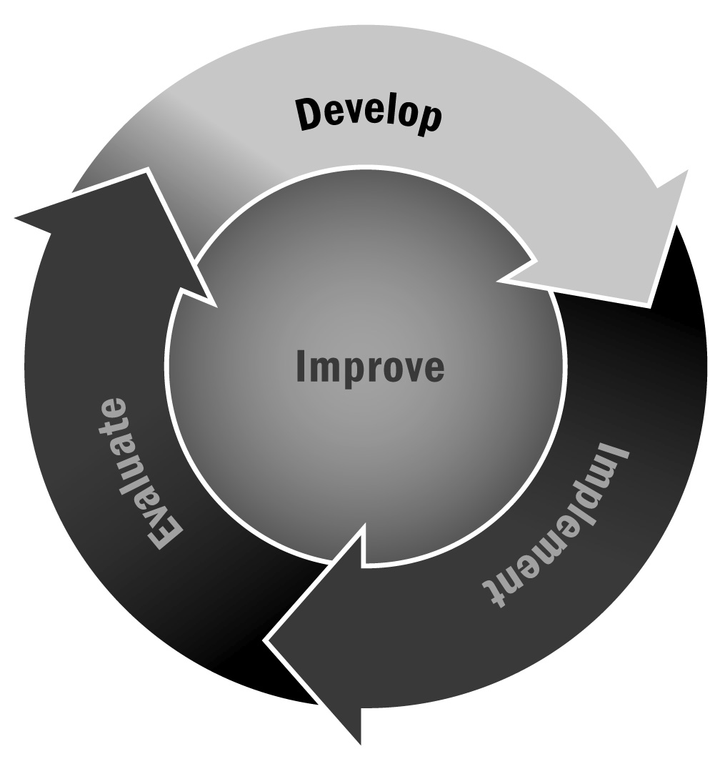
Asset Mapping
In Chapter 2, you learned that asset mapping is a great way to uncover the talents and skills of your staff, participants, family members, and community. You can use the assets you uncover to assist with your program planning.
Directions: There are multiple ways to do an asset map. This tool contains some tips and suggestions for developing your map and answers some questions you might have about the process. You can use this information to develop a process that will work best for you and your team.

Who Should Be Involved?
It is difficult to do asset mapping alone. We strongly suggest that you bring together a group to conduct the process. This can be one large group or several smaller groups of stakeholders. You may want to include staff, family members, older youth, community organizations, community members, program providers, school staff, etc. You can do several asset maps with individual stakeholder groups (youth, families, or teachers). Post all of the asset maps in a public place, and let people reflect on the commonalities or differences among them.

How Long Will Asset Mapping Take?
Asset mapping can typically be done in one meeting of approximately two hours. If you are engaging different groups of people, you may have several two-hour sessions.

What Kinds of Assets Should We Try to Uncover?
There are many different assets you can uncover through this process. Some of the most common are listed below, but be creative and think about what is in your own community.
- Skills and expertise in your community – Try to identify individuals and organizations with specific skills or expertise that can be turned into activities for your program. Maybe you have a theater company that can offer acting classes, a library that can host a weekly book club, or a strong local arts community with many individual artists willing to share their talents. Think about all of the types of organization in your community and what they have to offer (community-based organizations, hospitals, colleges and universities, arts organizations, etc.).
- Facilities in your community – Think about the facilities that exist in your community that might be useful to your program. These might include local parks with playgrounds, tennis courts, and sports fields; community centers with pools; colleges and universities with auditoriums, gymnasiums, science labs, etc.; arts organizations with specialized rooms or equipment such as a pottery studio or dance studio; organizations to support specialized sports instruction such as karate studios, horseback riding facilities, community sailing programs, tennis courts, gymnastics programs, etc.

- Expertise among your staff and community members – Identify the specific expertise among your staff, family members, and school partners (if you are a school-based program) that can contribute to your programming. Perhaps a teacher in your school is also a yoga instructor on the weekends. Maybe a family member of one of your participants is a chef. You may have a staff member with a degree in journalism. Consider how all the people in your community can contribute to your program options.
- Potential partners – Think about organizations and entities in your community that might make good partners. These might be organizations or businesses that could offer something to your program but would also benefit from being involved. Think about organizations with a mission that you could support—for example, a local environmental organization may have a goal of providing environmental education to as many young people in the community as possible, or a local museum may have a goal to reach out to more high-need youth.
- Potential funding sources – Take time to identify possible funding sources. These don’t have to be concrete or planned funders, but rather possible partnerships you could explore or create down the road. These might include local businesses, family foundations, United Way, etc. Think broadly for now.
Finally, ask people to name at least one asset that cannot be found easily. For example, participants may identify the best place to read a book, or a person to go to for advice. These are the most valuable kinds of assets!

How Should We Capture the Information?
Again, there is no right way to do an asset map. You might use clay, make lists, draw pictures, or create graphic organizers. To some extent, it depends on your preferences. Be creative and use the best format for you and your team!

