28

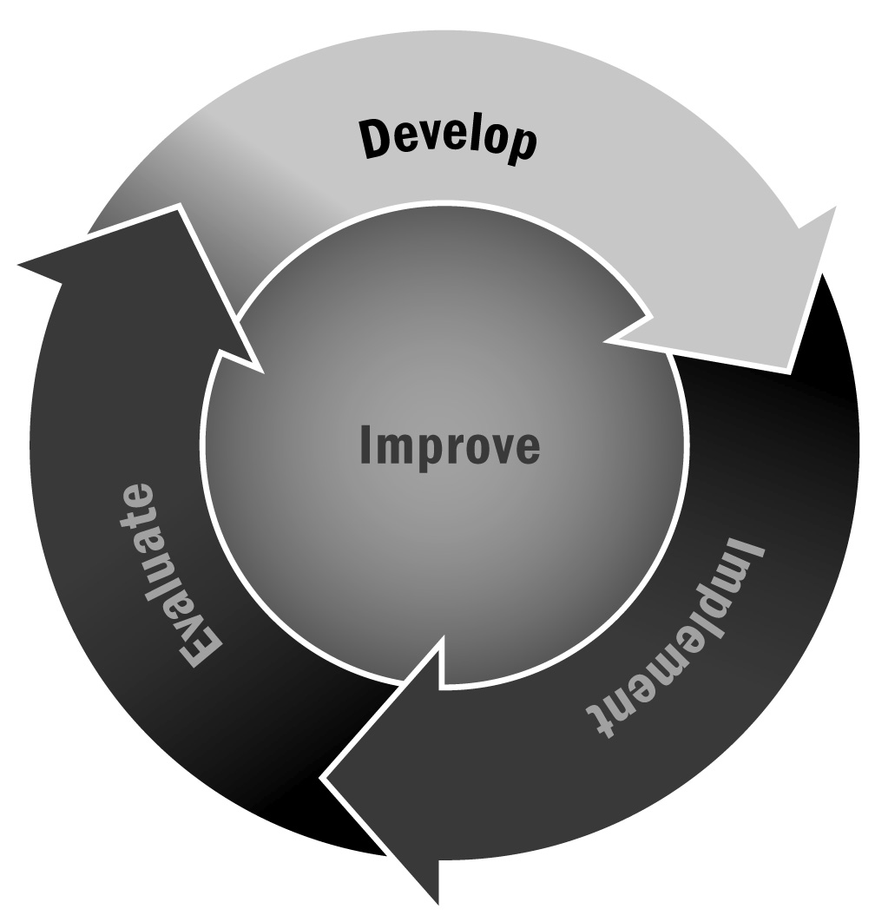
Developing a Communication Strategy
In Chapter 1, you learned that an effective communication strategy is critical to ensuring you meet your goals for two-way communication between your program and your stakeholders. You should design your communication strategy within the context of an overall visioning process that identifies assets and opportunities for your program. Use this tool as a starting point and, depending on your strategy, in conjunction with Tools 29 – 30.
Directions: Use the following list of questions to guide the design of your communication strategy. These questions should be used during the initial planning of the strategy and should be revisited periodically to ensure that your program’s communication efforts continue to meet the needs of your stakeholders. You can also use the table at the end of this tool to plan your strategy.
Objective(s)
- What do we hope to achieve with our message?
- Why are we communicating with our stakeholders?
- Does our communication align with our program vision, mission, and goals?
Audience(s)
- Who is our audience?
- What percentage of the community has school-age youth in public schools?
- What percentage of the community has school-age youth in private or parochial schools?
- What are the primary languages used in the community?
- Who are the primary employers in the community?
- What are the largest or most active faith-based communities, civic organizations, or other groups in the community?
- Have we identified all of our audiences?
- Have we targeted all messages appropriately to each audience?
- What kind of information does this group want or need to know about the program?
- How does this group like to receive its information?
- What is this group’s association with the program?
- How involved has this group been in the past?
- Does this group have leaders who influence the group’s opinions?
- What is the group’s familiarity or comfort level with the program?
- What is the level of trust between this group and the program?
- What is the level of support provided by this group to the program?
- Who is this group most comfortable receiving messages from?
- What are the major sources of news or information in the community?
Message(s)
- What is the key message we want to share with our audience(s)? What are the different components of this message that we want to share with different audiences?
- Does each message have a “hook” that will make the audience more likely to
pay attention to it?
- Is each message concise? Does it contain more than two main ideas?
- What language(s) should be used for each message, given its audience?
- What are the best formats for our messages?
- Is this message presented in an appealing, easily understood format?
- How will the target group feel when receiving each message?
- What reading level is required for this message?
Tools and Activities
- How will we share our message? Do we want to distribute newsletters? Flyers? Will we develop a website? Maintain social media accounts?
- How often will we communicate with our stakeholders and about what?
- Do we maintain an ongoing record of communication with each audience?
- Have we given one person or group ultimate responsibility for communication?
Resources and Timeline
- Have we said we would communicate in specific ways or at specific points during the school year or program cycle?
- If so, have we communicated the way we said we would?
- If not, what expectations do we want to set for how we will communicate with our stakeholders?
- What materials do we need to effectively communicate our message?
- Will we dedicate specific staff members to maintaining our communication plan? Do we have the staff and time to deliver each message?

Feedback and Improvement
- How will we assess the effectiveness of our communication strategy?
- Do we regularly review our communication strategy to ensure it is still meeting the needs of our audiences?
- Have we requested feedback using different formats that respond to the needs or preferences of each group?
- Have we requested feedback in a variety of locations and at a variety of times to take into account the varying needs or preferences of each group?
- Have we demonstrated that we listen carefully and respectfully to all audiences? How?
- Have we used the input of our audiences? How?
- Have we demonstrated to our audiences that their input influenced program decisions? How?

[Program Name] Communication Strategy
Objective | Audience | Message | Tools/  Activities | Resources | Timeline | Feedback
To share program information so our stakeholders are up-to-date | Youth | Short program reminders | - Updates via social media sites—Facebook, Twitter | - Need to set up online accounts, link to program website | - Daily | Will survey all stakeholders twice a year using the Communication Satisfaction Survey
 | Families | Sharing program schedule and changes or updates | - Email updates  - Posting on website  - Monthly newsletter | - Develop and maintain program website, email account  - Work with local printer to distribute monthly newsletter via mail and email | - Weekly emails and updates to website  - Monthly newsletter
 | Community members | Sharing program schedule | - Posting on website  - Monthly newsletter

