17

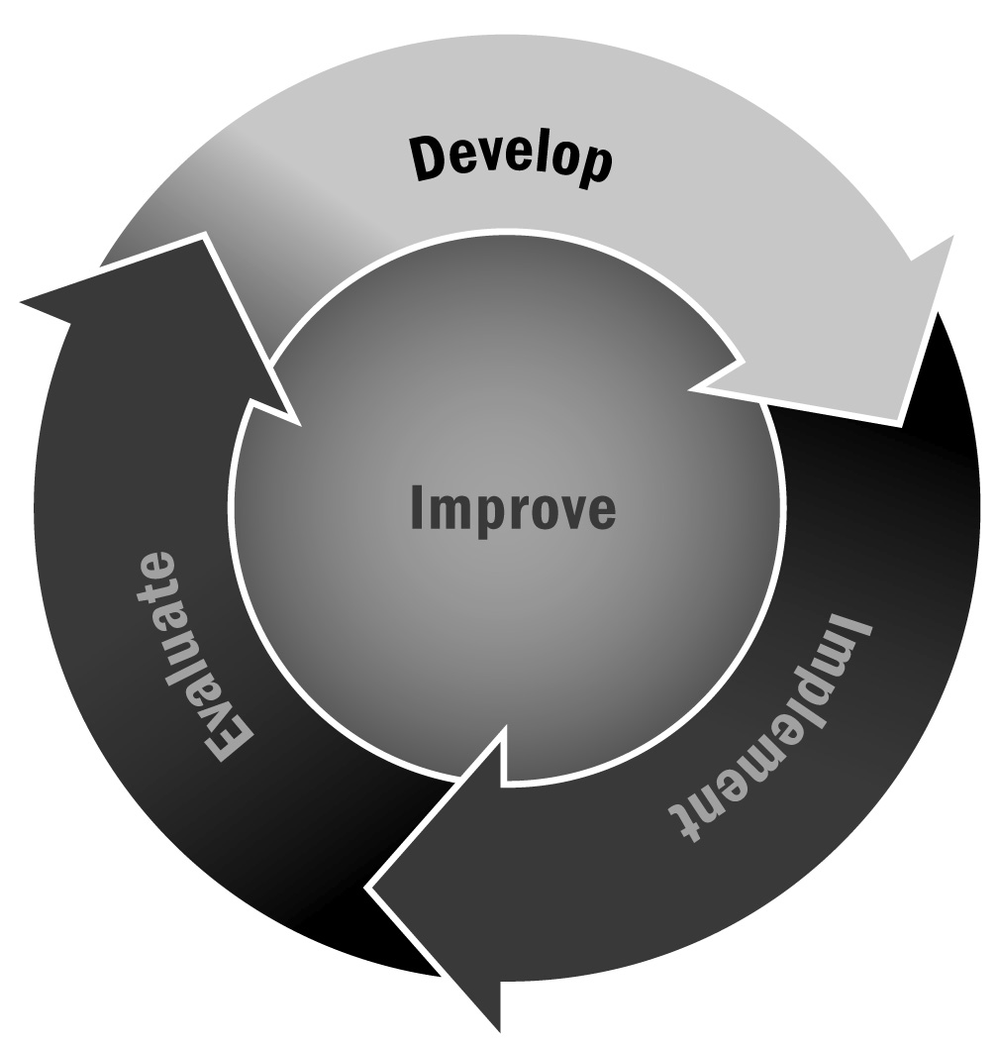
Budget Worksheet
In Chapter 1, you learned that it is important that someone oversees the budget by tracking revenue and expenses and planning detailed budgets for at least two years. Planning your revenue and expenses for two years will help you identify where you may have shortfalls, how many staff members you can afford to hire, the types of programming you can run, and the materials you can purchase.
Directions: Use this worksheet to help you think about the costs associated with operating an afterschool and expanded learning program. The first part of the worksheet lists potential funding sources and allows you to record the total amount of funding available from each source in order to compare your estimated costs with your estimated revenue. The second part of the worksheet provides an itemized list of typical expenses. For each item, record the estimated or actual cost.

Part I – Potential Resources
Potential Funding Sources | Estimated Contribution
Local government
School district
State grants
Federal grants
Foundation funds
Parent-teacher organizations
Local civic and service clubs
Local businesses
Tuition and user fees*
In-kind contributions
Other
Total Revenue

Part II – Typical Expenses
Item or Service | Estimated Total Cost/Fiscal Year
Management (percentage of staff time/salary for human resources, development, quality improvement, administrative)
Professional development
(internal and external)
Project staff member salaries
Contractual services
Fringe benefits
Annual rental fee/costs for modifying space
Furniture/equipment
Program materials
Field trips
Office supplies
Technology (phones, computers, tablets, printers) These are onetime purchasing costs, with upkeep (or depreciation) expenses thereafter
Utilities
Transportation/travel
Annual fees/licenses
Insurance
Total Costs
Total Revenue (from Part I)
Now, put the total revenue from Part I in the last row of your budget in Part II. Do the two numbers align? If so, then great! If not, you may need to adjust your anticipated expenses or make a more aggressive plan for bringing in revenue. Remember that in-kind, or donated, goods and services are a great way to offset costs at the start of a program. Use Tool 18 to learn more about in-kind contributions.
*Note: Participation must be affordable for families in the community. Be careful of fees that are too high and that make the program inaccessible for families.

