Help Students Identify and Meet Career Goals
2014 Illinois 21st CCLC Spring Conference
May 1, 2014
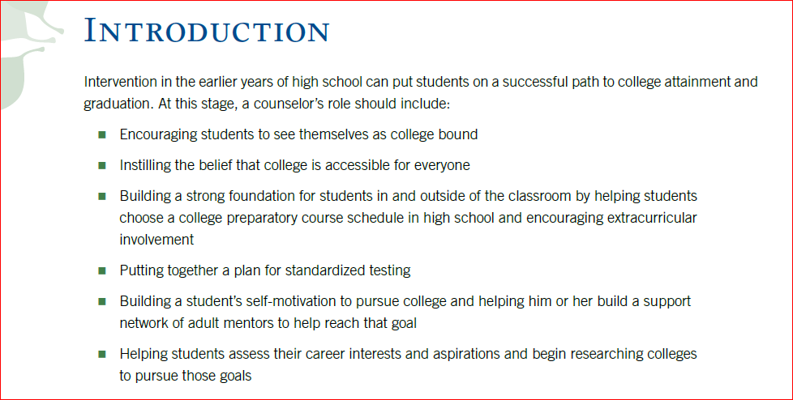
Excerpts Reprinted with permission from the National Association for College Admission Counseling, 2014.
Access the NACAC Early High School .pdf, “Step-by-Step to College Workshop for Students” curriculum available on Edmodo for lesson and activity suggestions.

An Equal Opportunity/Affirmative Action Employer
This publication was prepared pursuant to a grant from the Illinois State Board of Education and is funded 100% through the federal Carl D. Perkins Career and Technical Education Improvement Act of 2006. The total amount of federal funding involved is 100%, which represents 100% of the cost of producing the publication.

Edmodo Access

Steps:
- Edmodo.com
- Sign up as a “I’m a Teacher”
- Fill out the appropriate form
- Go to “Groups”
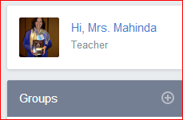
- Click the + sign
- Choose “join”
- Type in the Group Code nbxfmn
- Close

Post-Secondary Options
Resources:
- See Edmodo, ISBE 21st CCLC group, Folders—Career Resources
- Ilcte.org, Helpful Links for Career Exploration and Resources

An Equal Opportunity/Affirmative Action Employer
This publication was prepared pursuant to a grant from the Illinois State Board of Education and is funded 100% through the federal Carl D. Perkins Career and Technical Education Improvement Act of 2006. The total amount of federal funding involved is 100%, which represents 100% of the cost of producing the publication.

