94

Sharing Evaluation Results
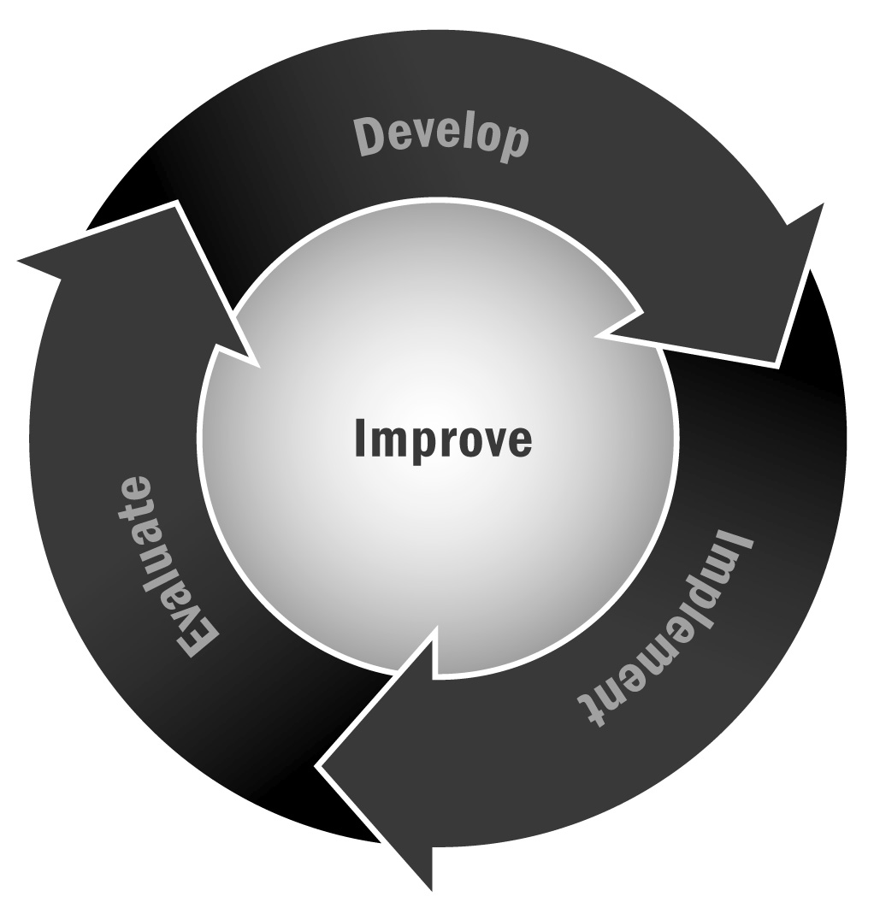
In Chapter 6, you learned that it is important to use your evaluation results in a variety of ways—for planning purposes, to spread the word about your program, and to promote a culture of continuous improvement. Sharing your evaluation results with your staff members, partners, funders, and participants can help ensure they get used for improvement.
Directions: This tool provides information about the types of people with whom you may want to share evaluation results, the purpose for sharing them, and tips on the best way to share the information with each stakeholder group. You’ll have to adapt the tool to your own community and circumstances, but this can get you started thinking about the best way to share your results.

Sharing Evaluation Results
Stakeholder Group | Purpose for Sharing | Tips and Tricks
Staff | - Planning for program improvements  - Celebrating success | - Bring evaluator to planning meeting to explain results.  - Prioritize using Tool 92: Post-Evaluation Planning Tool to prevent frustration.
Program Providers | - Planning for program improvements  - Celebrating success | - Share the executive summary and action planning results.  - Share results that are relevant to their work with youth in the program.
Funders | - Conveying value of their investment  - Identifying concrete plans for improvement  - Encouraging new funding | - Share positive evaluation results immediately and give them credit for funding a successful innovation.  - Own negative results. Before sharing, be sure you have specific and targeted plans for improvement that you can describe.  - If you create a brochure, media release, or other public-relations document to highlight positive evaluation results, be sure to give your funders credit.  - Share marketing and outreach materials with potential funders to promote key aspects of your program.
Community Partners | - Celebrating success  - Identifying concrete plans for improvement  - Encouraging partnership | - If your partners are active in your program’s implementation, include them in the planning process. If they are more symbolic partners, treat them more like funders by celebrating their role in success and sharing negative evaluation findings only after you have a concrete plan to address them.
Families | - Marketing program effectiveness  - Sharing plans for improvement  - Recruiting new participants | - Families want to know their child is attending a worthwhile program. Use positive evaluation results to underline the value of their child’s experience.  - Use positive results in marketing materials to attract new families.  - Make sure evaluation results are clear and in lay terms. Translate them into other languages as needed and appropriate.
Youth | - Marketing program effectiveness  - Sharing plans for improvement  - Recruiting new participants | - Keep it simple. Share key points in easy-to-understand language (e.g., “This program is helping young people like you feel more confident.”)  - If youth were involved in surveys or observations, let them know the results of the evaluation in terms of their role (e.g., “You told us…”).  - Let youth know you are going to improve the program to make it better for them, but use general terms. (e.g., “We heard that you don’t always feel safe in this program, and we want to fix that by…”).
School District | - Sharing program impact on school-related indicators  - Encouraging partnership  - Highlighting areas for improvement | - Treat school and district staff members as you would funders, even if they are key partners. Schools want to know that programs are benefitting the young people who attend them. Share key points in succinct, easy-to-understand language.  - As with funders, share negative evaluation findings after you have developed a plan for improvement.  - Focus on how your results will help youth thrive in school.
Local Government (city/town council, mayor’s office, local legislators) | - Influencing policy  - Encouraging partnership or public funding | - Be brief and clear! Use bullet points and boil evaluation findings down to understandable sound bites. Never use more than one page to explain your findings.  - Lead with the positives.  - If the program has city or county funding, offer local politicians the opportunity to get their photo taken with youth in the program as part of a press release about positive evaluation findings.  - Don’t hide negative evaluation findings. Own them but be ready to share how you are already addressing them.

