22

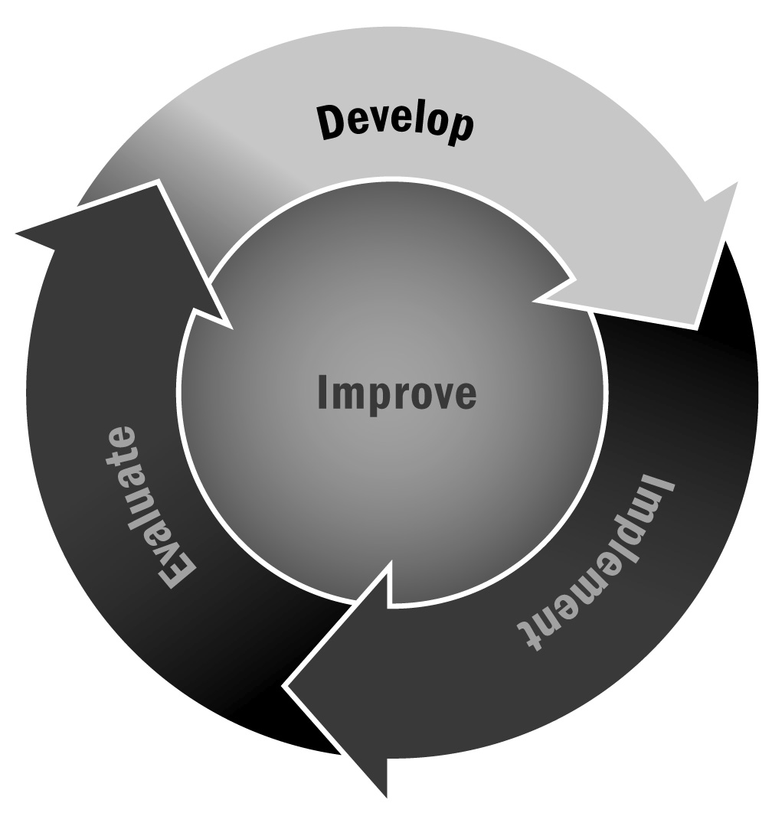
Sample Interview Questions
In Chapter 1, you learned that your staff is central to the success of your afterschool and expanded learning program. You can create perfect policies and procedures, have a strong management system, and develop great programming, but your program won’t be successful without a great staff. For this reason, it is critical to recruit, hire, and retain staff members who are passionate about working with young people, creative and thoughtful, and committed to their work.
Directions: The lists below contain examples of questions you may use when interviewing candidates. This is a comprehensive list, so select the questions that best fit your needs. An interview should include about 10 good questions with some prompts and opportunities to elaborate.

Tips for a Good Interview
- Start by introducing yourself and the program. Explain the job in greater detail.
- Ask a couple of general questions about why the candidate is interested in the job and his or her background and experience with youth.
- Include several questions that allow the candidate to reflect on his or her strengths and what he or she can bring to the program.
- Make sure your questions are open-ended and that they allow room for elaboration.
- Be sure to leave time for the applicant to ask questions, too.
- If you are interviewing more than one person for a position, be sure to ask all candidates the same questions.
- End the interview by providing information about your process (e.g., how many people you are interviewing, how many rounds of interviews there will be, and when you expect to make a decision).

Questions About Background and Experience
- Why are you applying for this job?
- Tell us about your experience working with young people.
- What previous experience have you had working in afterschool and expanded learning programs?
- What do you think are some of the most important qualities of a youth development staff member in an afterschool and expanded learning program?
- What are your short- and long-term career goals?
- What do you like about working with youth?
- Can you describe a challenging work situation and how you handled it?

Questions About Personal Qualities
- What do you consider to be your greatest strengths? Weaknesses?
- What motivates you to put forth your greatest effort?
- What two or three accomplishments have given you the most satisfaction? Why?
- What kind of work environment are you most comfortable in?
- How do you work under pressure?
- What two or three things are most important to you in your job?
- What contributions do you see yourself making to this job?
- Can you describe a time when you have had to work in a team? How did you make that a successful experience?
- Describe your working style.

Questions for Candidates for Leadership Positions
- How would you describe your management style?
- Tell us about your experience:
- Supervising staff
- Coordinating program schedules
- Planning programs
- How would you go about building relationships or partnerships with the community? Local businesses? Local government? Other programs? Schools?
- Give us some examples of things you would do to make families feel welcome at the program.
- How would you go about planning programming for the school year? For the summer?
- What two or three things are most important to a successful afterschool and expanded learning program?
- What qualities would you look for in staff?

Questions for School-Based Programs
- How would you go about building a relationship with your principal? With school faculty?
- What do you see as the role of an afterschool and expanded learning program in a school setting?
- How can an afterschool and expanded learning program support what goes on during the school day?

Questions for Potential Activity Leaders
Many programs look for staff members to offer classes or activities. These people may be volunteers, teachers at the school, or employees of other agencies. You can use the following questions for these interviews:
- Describe the class or activity you can offer.
- What do you hope participants will gain from your class or activity? What skills do you try to help youth develop?
- How do you incorporate opportunities for youth to have leadership in your program?
- How do you build a sense of community in your program? What do you find works best to promote a positive environment in your program?
- Tell us about a challenging experience in your program and how you handled it.
- Why do you like working with youth? With adults?

